Dosing tank
Top quality tank for dosing chemicals storage. Tank is made of PE material with semi transparent white color an thick wall.
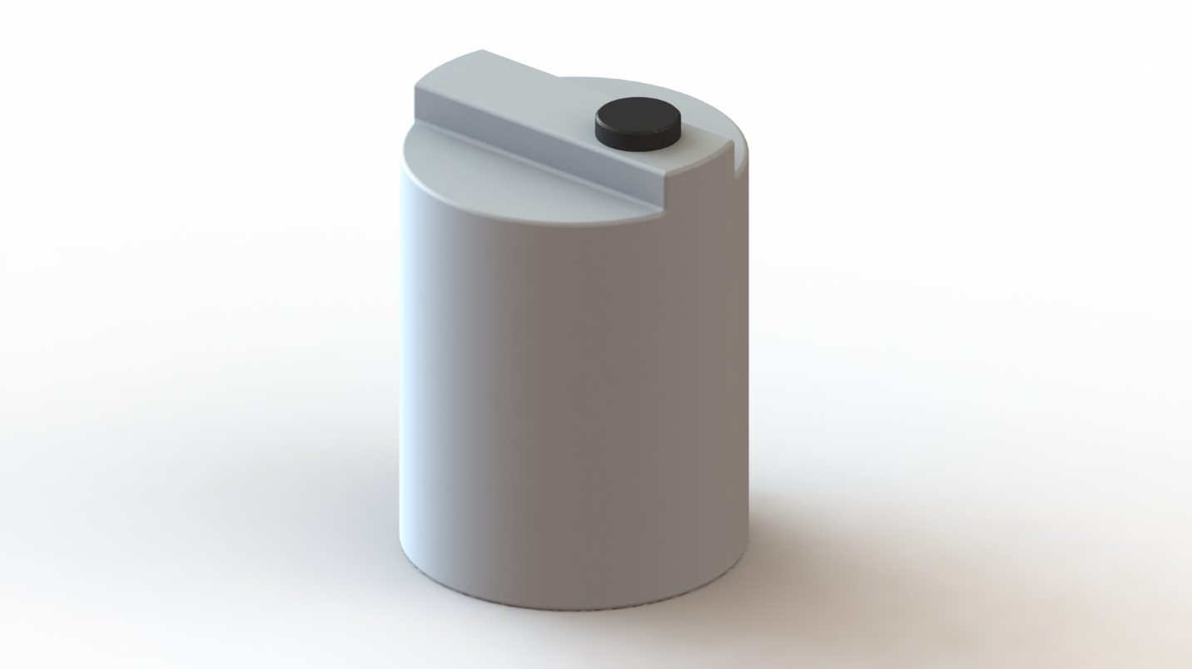
Large cover diameter and its fine production together with an additional plug allows easy pouring occasional sediment removal.
The tank is graduated with 10 liters divisions.

Tank dimension
Useful volume 100 liters:
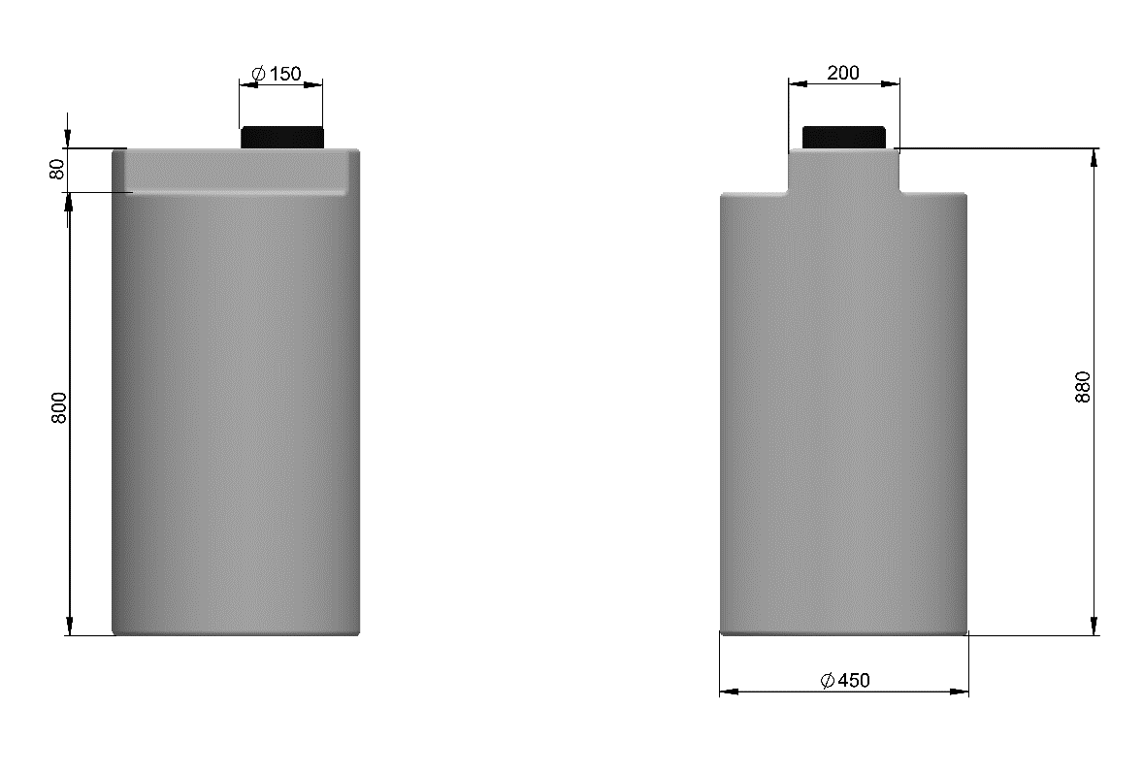
HIDROSANITAS
Useful volume 200 liters:
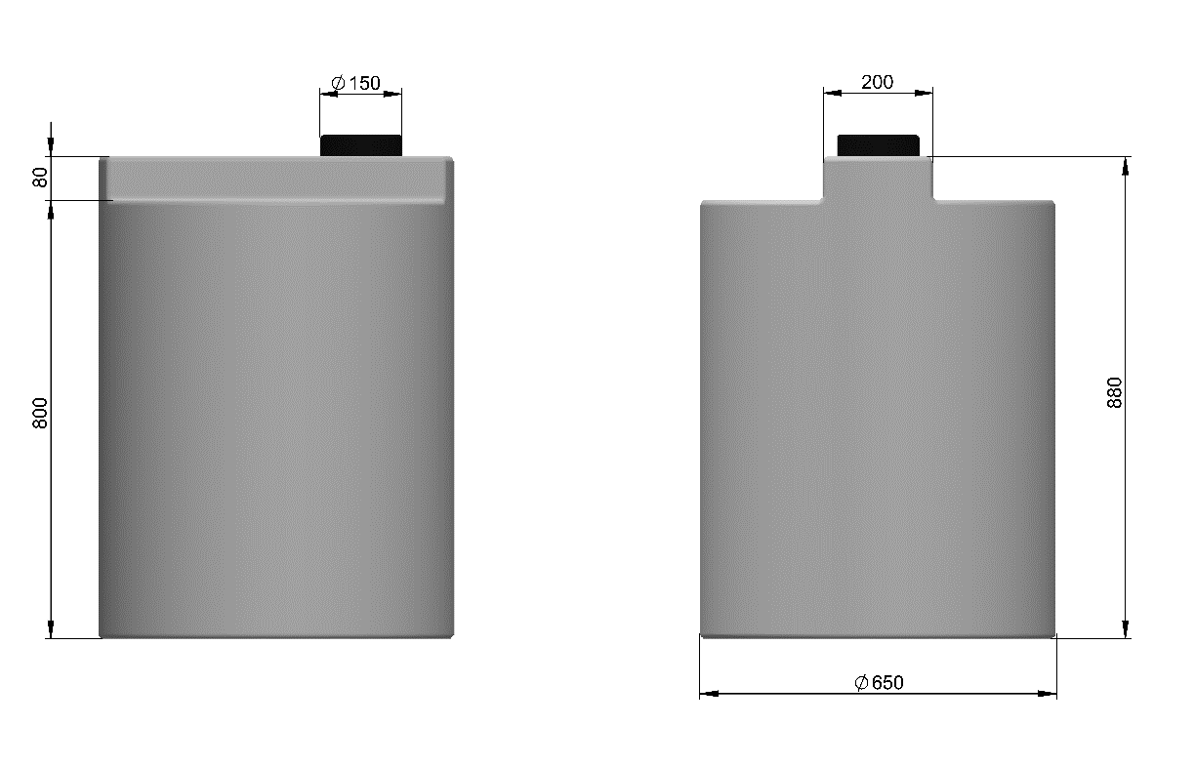
HIDROSANITAS

