Dosing container rectangular 50 lit
Top quality tank for dosing chemicals storage. Tank is made of PE material with semi transparent white color an thick wall. Rectangular base allows suitable arrangement even in very confined space. Two level upper surface in combination with thick wall allows production of compact systems in combination with dosing pump, mixer, level probe and other elements which goes with dosing systems.

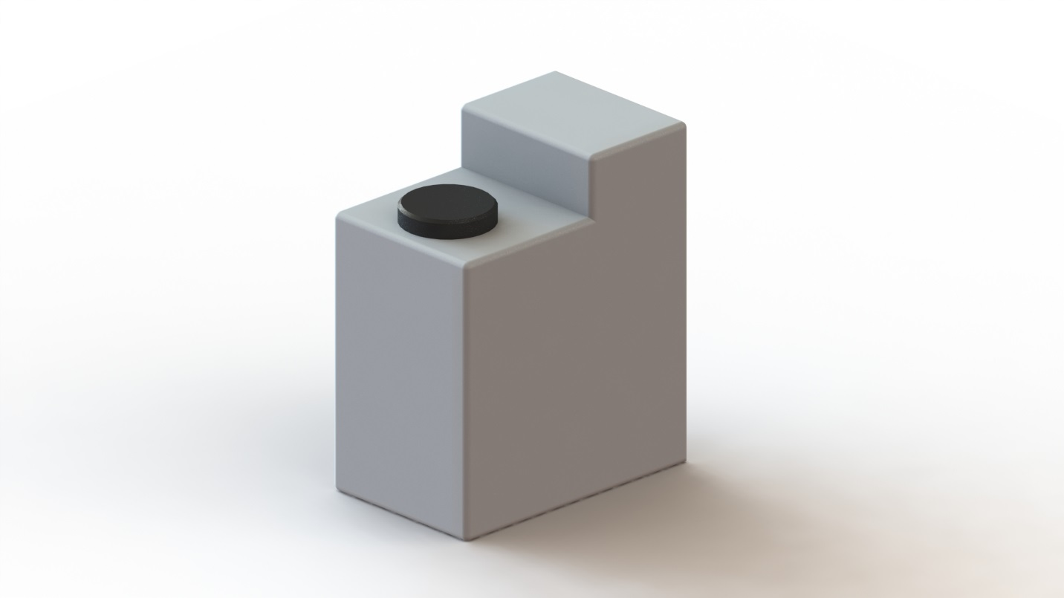

Large cover diameter and its fine production together with an additional plug allows easy pouring occasional sediment removal.
The useful volume is 50 liters and it’s marked. The tank is not graduated, but given its proper base, it can be done easily.

Dimensions:
Width 290mm, length 460mm, highest part height 550mm, height of part with lid 450mm, opening diameter 140mm (lid Ø150 mm).
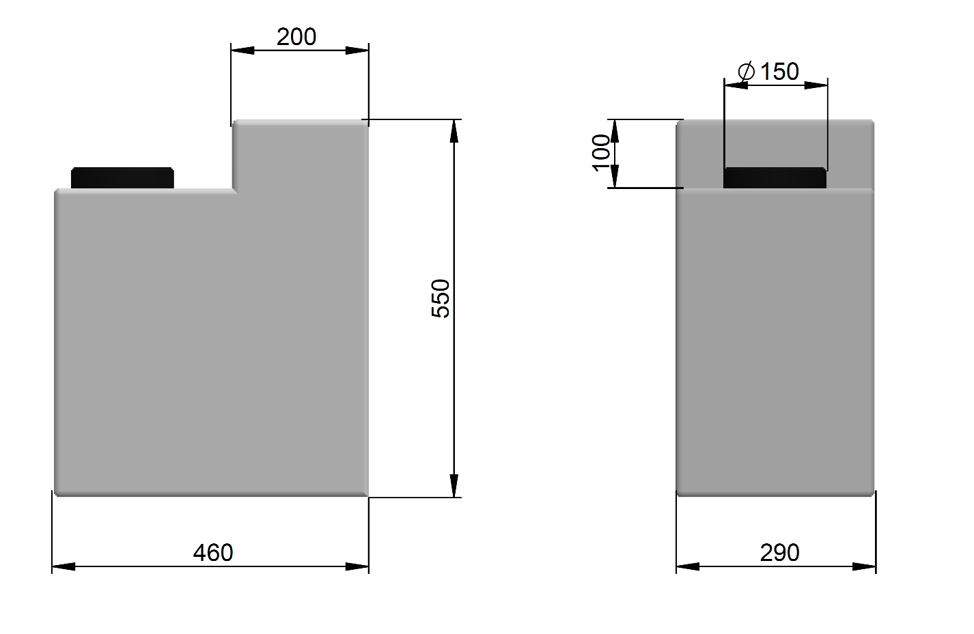
HIDROSANITAS

